**News**

**Dahua Held 5th Partner Day to Foster an Inclusive and Collaborative Ecosystem**

October 20, 2023 / Ibiza, Spain. Dahua Technology, a world-leading video-centric AIoT solution and service provider, recently held its 5th Partner Day in the picturesque coastal city of Ibiza, Spain. Under the theme "Think# as One", the event highlighted Dahua's dedication to expanding partnerships in technology, business, service and multiple fields, jointly creating a mutually beneficial and win-win ecosystem for the sustainable development of the AIoT industry.

The grand event witnessed the presence of more than 370 distinguished leaders and representatives from key sectors such as cybersecurity, smart city, transportation, retail, energy, and education across Europe. In addition to technical partners, this event also brings together system integrators, end users, and organizations from various fields to share successful experiences, discuss industry trends, as well as explore business opportunities, demonstrating the growing importance of fostering collaborative efforts in the digital age.

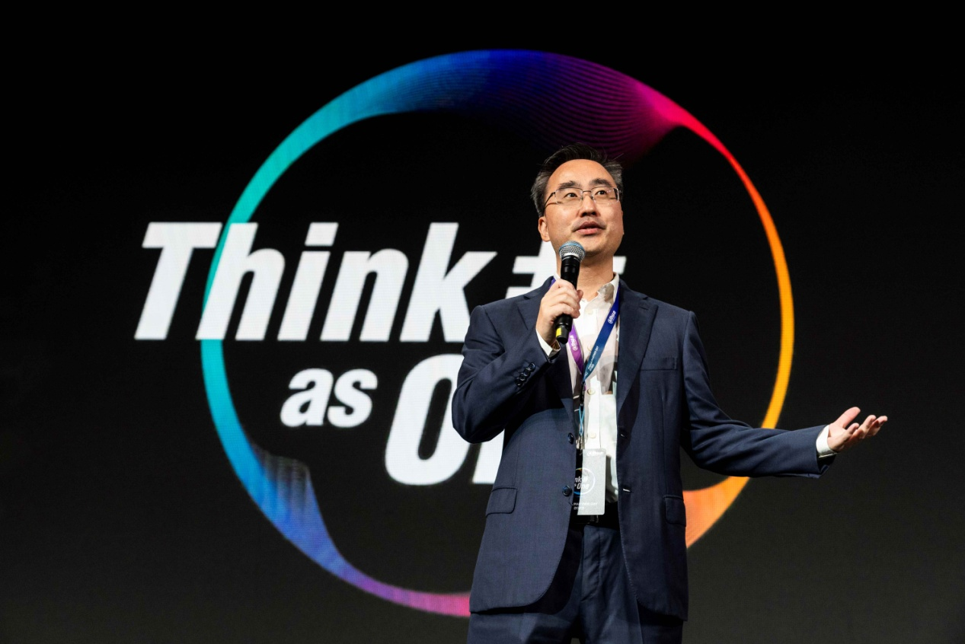

Mr. David Shen, President of Dahua WEU, opened the event by expressing his gratitude to the attendees. His opening remarks delivered the core message of this year’s Partner Day event, which aims to comprehensively collaborate with diverse fields including hardware, software, training, certification and delivery, working as one to create a more inclusive and collaborative ecosystem.

In the following keynote speech, Mr. Neil Ni, Vice President of Dahua Global Business, emphasized the importance of partnerships with ecosystem collaborators and their role in facilitating innovation and mutual growth in the ever-evolving digital landscape. He shed light on the rapid growth of the digital industry, especially in Europe, where AIoT advancements have significant impacts on the intelligent and green development of energy, transportation and building sectors.

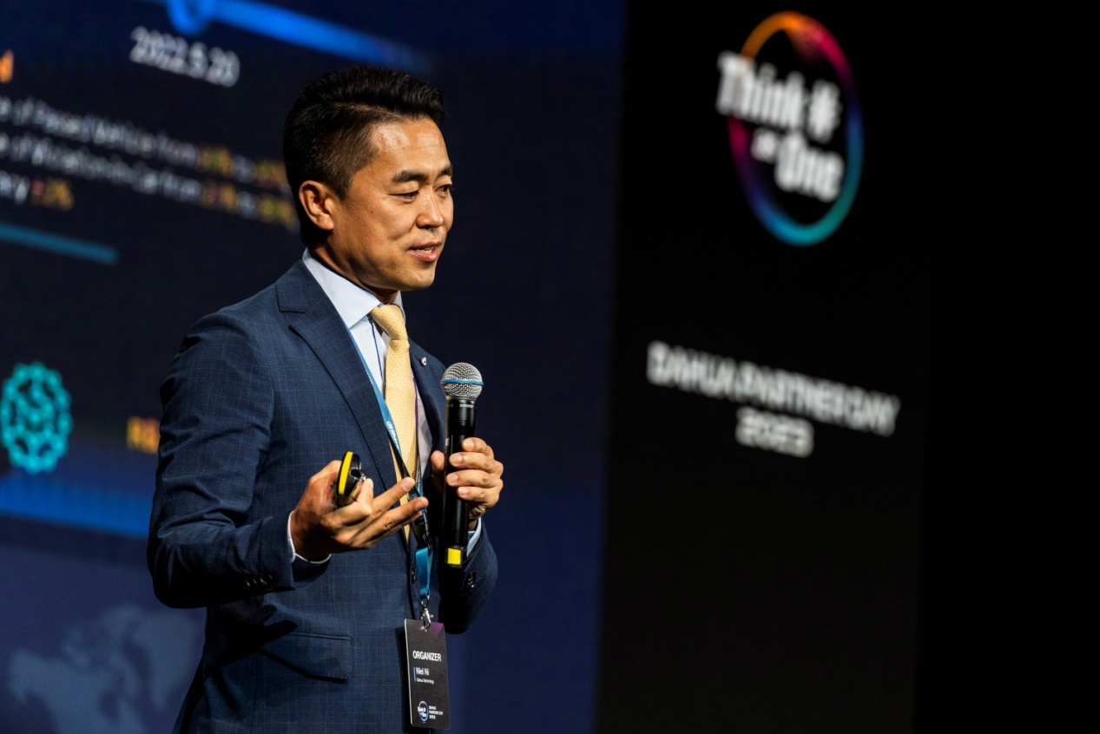

Aligning with the company’s business strategy and core AIoT capabilities, Mr. Ni outlined Dahua's ecosystem strategy in three key dimensions: awareness, framework, and operation, and how these contribute to the success of both industry customers and ecosystem partners. He stressed that Dahua will further deepen its ecosystem and open up capabilities at multiple levels including business, technology, and services to enhance experience and benefits of partners. “By combining our strengths, we can co-create value-driven solutions that transcend boundaries and address complex challenges. Through mutual empowerment, we can expand market reach, enhance product portfolios, and achieve sustainable growth that benefits all stakeholders,” he concluded.

Furthermore, Mr. Ni also highlighted Dahua's commitment to providing fast and flexible localized solutions and services to meet the diverse needs of customers. He shared an example of Dahua's collaboration with the Egyptian Traffic Authority to develop a smart violation detection system, showcasing Dahua's differentiated adaptability and R&D advantages.

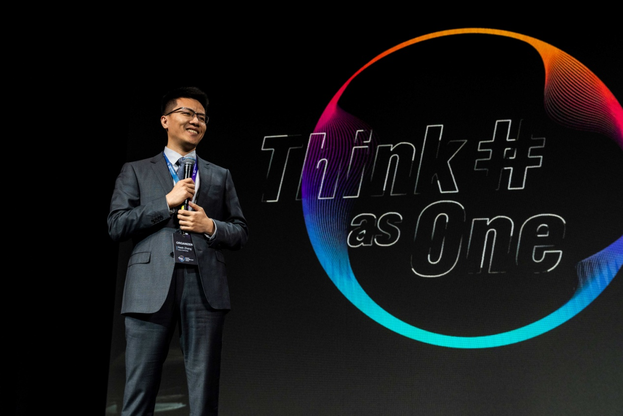

The value and potential of digitalization was further discussed by Mr. Nash Zhang, Managing Director of Dahua Global Enterprise Business, who mentioned EU’s accelerated digital transformation in four key areas, including infrastructure construction, enterprise transformation, public services, and talent cultivation. He went on to share Dahua's application projects in aiding the digital transformation of industrial parks, education, and energy enterprises, as well as its active participation in low-carbon zone management in countries such as Spain, which has a positive impact on a safe, efficient, and green future.

“In the past few years, we have provided services to over 5,000 overseas partners, including over 300 solution partners. We also work closely with ecosystem partners to cultivate new vertical areas and markets. We provide them with guidance, technical support, skill training, and market resources, co-creating the future of AIoT,” said Mr. Zhang.

Driven by The European Commission and the EU’s digital education policies, more and more schools and educational institutions are embracing innovative and modern means to enhance students' engagement and learning experience. This includes the [International School on the Rhine (ISR)](https://www.dahuasecurity.com/newsEvents/successStories/147/1597) in Germany and [Asociación Sí Puedo Los Alamos](https://www.dahuasecurity.com/newsEvents/pressRelease/8847) in Spain, in which Dahua’s [DeepHub Smart Interactive Whiteboards](https://www.dahuasecurity.com/singlePage/custom/Dahua-DeepHub-Smart-Interactive-Whiteboard) assisted in upgrading their teaching devices for more efficient and interactive classrooms.

A roundtable discussion regarding digital education was conducted among distinguished experts in the education industry, delving into the local challenges and trends faced by education in different countries, the level of digitalization and IT, the balance of educational resources, and the advantages of online classrooms. It provided valuable information about the development of a high-performing digital education ecosystem in Europe.

The event also showcased insights into Dahua’s commitment to strengthening open collaboration in the field of cybersecurity. These include an informative presentation from SGS Brightsight focusing on Dahua’s Common Criteria EAL2 and EAL3 assessment and certification, as well as an in-depth outlook at Dahua’s thermal imaging product testing project shared by CNPP. “Cybersecurity is Dahua’s top priority. We have been exploring and applying industry best practices to ensure the security of our products and customer privacy and data. We will continue to consolidate our security capabilities, strengthen deep cooperation with third-party organizations such as SGS Brightsight and CNPP, to help customers comply with GDPR and better respond to today's cybersecurity challenges,” said Mr. Shen.

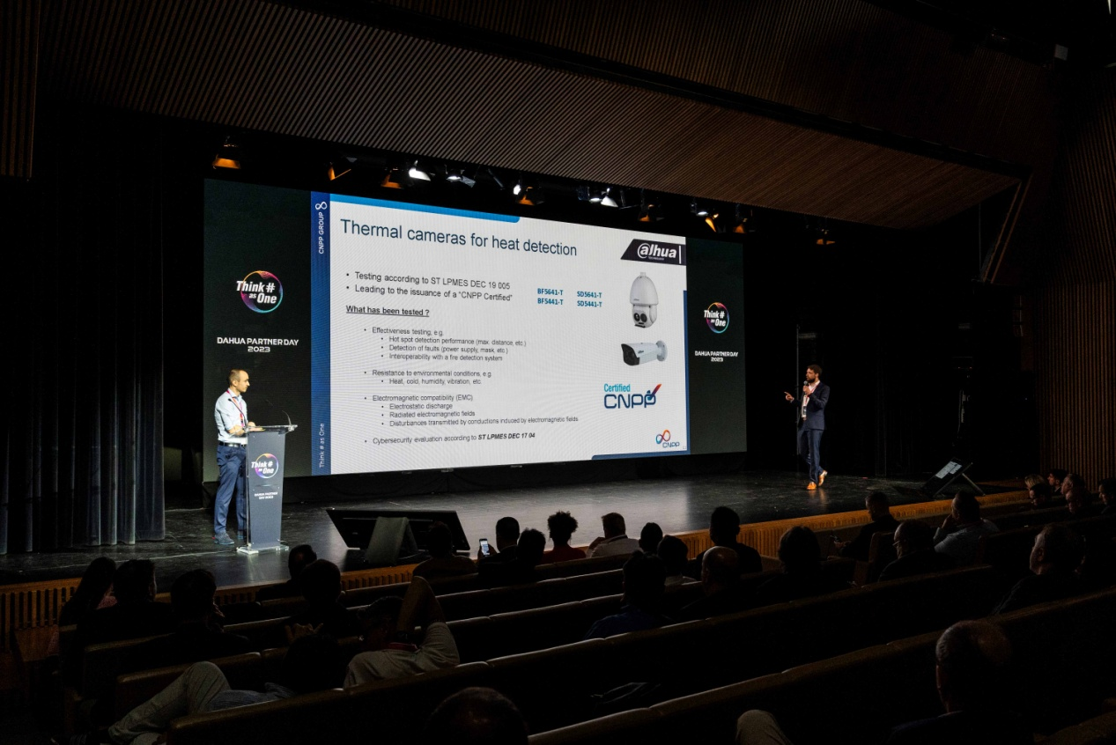

Alongside certification partnerships, cybersecurity experts unanimously believe that device suppliers, industry organizations, system integrators, users, and certification agencies from all walks of life should assume respective responsibilities, work together to address this common challenge, and jointly create a more trusted and secure world.

As one of the most important strategic initiatives of the company, Dahua always values open and comprehensive cooperation, committed to creating value for its partners, growing together with them, and contributing to their greater success. The Partner Day demonstrated the company's dedication to innovation, collaboration, cybersecurity, and the advancement of AIoT solutions. It served as a prominent platform that connects key industry players to explore new breakthroughs and opportunities, and empower various industries through technology integration and joint solutions.

“We are collaborating with Dahua in shopping centers and the retail sector to bring intelligent and joint solutions. Flame combines computer vision with a broad range of data to enhance decision-making that maximizes visitors’ value and enhances overall venue performance. Together, Dahua and Flame have developed a data-intelligent solution that, thanks to AI, improves management and helps physical spaces understand customer and visitor behavior. We look forward to innovating more with Dahua and to exploring more cooperation opportunities," said Mr. Jonathan Solís, CEO of Flame Analytics.

As the digital landscape continues to evolve, Dahua will remain dedicated to fostering an ecosystem of cooperation and innovation, jointly contributing to a green, safe, and efficient digital world.

_____________________________________________________________________________

***About Dahua Technology***

*Dahua Technology is a world-leading video-centric AIoT solution and service provider. Based on technological innovations, it offers end-to-end security solutions, systems, and services to create values for city operations, corporate management, and consumers. With more than 23,000 employees (over 50% R&D technicians), Dahua has deployed its products, solutions, and services in 180+ countries and regions, covering key industries including smart city, traffic management, building, retail, banking & finance, education, energy, and more. With in-depth insights and layout of AIoT, Dahua continues to explore emerging fields and has already established businesses including Imou, iRAYPLE, Pixfra, Waythcan, Wisualarm, Dahua Memory, etc. According to Omdia, Dahua is estimated to have been the second largest supplier of video surveillance equipment to the world in 2022.*

*To learn more, visit the* [*Dahua*](https://www.dahuasecurity.com/newsEvents/blog) *Blog or follow us on*[*Facebook*](https://business.facebook.com/DahuaHQ/)*,*[*LinkedIn*](https://www.linkedin.com/company/dahua-technology/)*,*[*YouTube*](https://www.youtube.com/user/DahuaTechnology)*and*[*Twitter*](https://twitter.com/DahuaHQ)*.*

***Media Contact***

[PR_Global@dahuatech.com](mailto:PR_Global@dahuatech.com)